Abstract

Accessibility to information being the order of the day, it is of utmost importance how easily one can access the information relevant to his needs.

Web has become the warehouse one looks to access information. Due to the sheer volume of data and unauthentic, unwanted information present, the challenge to seek relevant information has become even more arduous.

Here relevance means most appropriate and connected information. The inherent limitations of conventional key-based searching techniques often neglect the underlying semantics of the information. Here we propose a way to preserve semantics of a documents to yield better search results to end user.

Content from the web is crawled at regular basis, this content is provided as output to user based on his query. Which document is relevant to the query given is the core problem for existing search engines.

This document discusses the method that can be used to infer context on the user’s query, as well as the document that is talking about the same context.

LIST OF TABLES

Table No. Table Name Page
1. Words to know 4
2. Abstract Requirements 5
3. FireUP module arguments 17
4. PDU fields 18

LIST OF FIGURES

Figure No. Description Page

1. Architecture Diagram 8

2. Sequence Diagram- 9
Start-up

3. Sequence Diagram- 10
Boot up of Slaves

4. Design of Index table 11

5. Sequence diagram- 12
Result Generation
6
6.1 Class Diagram-Master A3 13
6.2 Class Diagram-FireUP module 14
6.3 Class Diagram-RGEN 15
6.4 Class Diagram-DMGR 15
LIST OF SYMBOLS AND FAMILIARS

Words To Know

SYMBOL: | MEANING:
Content | Text content from webpage
Crawling | Act of recursive visit from one link to another
Master | Managing module
Slave | Worker module
FireUP | Module used to initialize activities in this project
FFC | Fetch From Crawler module
RGEN | Result Generator module
DMGR | Data Manager module
PDU | Data encapsulator and communicator
Rank | Number indicating trustworthiness of a page
Context | Implied situation, circumstances that alter the meaning of words.
DS | Data Server
CMS | Crawler managing System
CRS | Content Retrieval System
QS | Queueing System
NLP | Natural Language Processing module

2. REQUIREMENT ANALYSIS

2.1 Abstract Requirements

R1 | Collection of initial links to visit.
R2 | Visit the web page following the link
R3 | Fetch the contents of the web page.
R4 | Filter through the web page content.
R5 | Analysis of authenticity of a web page (Assigning rank)
R6 | Store the contents of the page.
R7 | Keep track of all the links the web page has cited.
R8 | Forward the content of a web page for Indexing
R9 | Receive content from content-retrieval system
R10 | Identifying the context
R11 | Storing the content in easy-to-retrieve way
R12 | Input and Processing of the query given by the user
R13 | Finding relevant documents
R14 | Output the links of relevant documents to the user

2.1.2 Non-Functional Requirements and sub-requirements
NR1: The content retrieval is to be done in distributed manner.
NR2: Adopting appropriate protocol for communication.
NR3: Designing a standalone application to start the content retrieval system.
NR4: Adopting heartbeat signals for status probing and debugging
NR5. Maintaining a proxy-to-original link lookup table.
NR6. A probing system which periodically probes the applications and records their status.
NR6.1. heartbeat signals is maintained for each module in the system.
NR7: An UI for monitoring the status of the system.

Functional Requirements and sub-requirements

Detail Analysis Of Requirements

R1: Collection of initial links is based on following criteria
R1.1: Websites having larger visits are collected.
R1.2: Websites serving as hubs to other websites are selected.
R1.3: Priority is given to authentic information.

R2: Visit the web page
R2.1: Use appropriate data-structure to maintain.
R2.1.1: The number of visits for that page.
R2.1.2: Modifications/ updates for that page
R2.1.3: Calculate the frequency of visit for that webpage.

R3: Calculating Authenticity /Rank of a page
R3.1: Ranking algorithm to take account of inward links to the page.
R3.2: Number of hits to the page.

R4: Fetching the content of the page
R4.1: Need to keep bandwidth utilization efficient by keeping domain IP address mapping technique.

R5: Filtering Contents
R5.1: Omission of following:
R5.1.1: Removal of Ads
R5.1.2: Spam detection
R5.1.3: Avoiding loops
R5.1.4: Parsing "robots.txt"

R6: Storing the Contents.
R6.1: Storing the contents in the file System.

R7: Keeping track of links
R7.1: Data-structure to store link information (Queue).
R7.1.1: Updating with new links obtained on visit of a webpage.
R7.1.2: Removing the link after it's visit.

R8: Forward the content.

R9: Receiving content from content retrieval system for Indexing
R9.1: Booting a network of slaves for a master.
R9.1.1: An application `FireUP` to boot the slave network.
R9.1.2: Communication with the CMS Master for configurations of its client.
R9.1.3: Booting up the slaves of the system to connect with the Master.
R9.2: Fetch the scrapped content from crawlers.
R9.3: Implement a generic and efficient protocol for communication

R10: Identifying the context.
R10.1: Categorizing the contents based on context.

R11: Storing the web content in easy-to-retrieve way (Indexing)
R11.1: Indexing the document based on the keywords.
R11.2: Receiving search queries from `RGEN`s and serve the relevant links.

R12: Query Processing
R12.1: Receive input Query from the user through UI.
R12.2: Spell check and filtering on the query.

R13: Fetching the results for the query given by the user
R13.1: Categorizing the query and distributing the query to DMGRs.
R13.2: Sort the links retrieved from the DMGRs and presenting to the user.

R14: Output the links of documents.
R14.1: Links of the documents are wrapped and output to UI.
R14.2: Host a web server for users to interact.

2.2 Concrete Requirements

R9.1.1: An application `FireUP` to boot the slave network.
Requirements.
A standalone application -
- Which can be installed in all the machines in the system.
- Which boots the CMS master and A3.master.
- Which connects to master specified at the time of initialization.
- Which receives the requests from the masters to create, kill different processes specified.
- Which allows the user to manage the processes in that machine.

Manage: {create, kill, and view errors and output}

R9.1.2: Communication with the CMS Master for configurations of its client.
- Getting the configuration of the CMS Master.
- A standard format for configuration of the whole system such as JSON. [NF]

R9.1.3: Booting up the slaves of the A3 system to connect with the CRS.
- Creating the FFCs and DMGRs for each crawler in the CMS system
- Connecting the FFCs and DMGRs.

R9.2.1: Fetching the scrapped web-content from the connected CRS.
- Efficient retrieval of content by FFC’s adhering a protocol.

R10.2: Categorizing the content.
a. Choosing a language model for categorizing the web-content.

R11.1: Indexing the document based on the keywords.
a. Storing the minimized document.
b. Indexing the above minimized doc for the keywords in it.

R12.1.1: Spell Check
a. Limited spell correction using dictionary
R12.1.2: Selective Omission
- Omit unwanted symbols, white spaces to form set of keywords

R13.1: Categorizing the query and distributing the query to DMGRs.
- Categorizing the query using some language model or sentment analyser.
- Sending the query to respective `DMGR`s for getting the links.

R13.2: Sort the links retrieved from the DMGRs
- Sorting is decreasing order of ranking

R14.1: Output the sorted results to UI.
a. Wrap the whole set of links in PDU and send to UI module.

3. DESIGN

3.1 Architecture Of Content Retrieval Mechanism

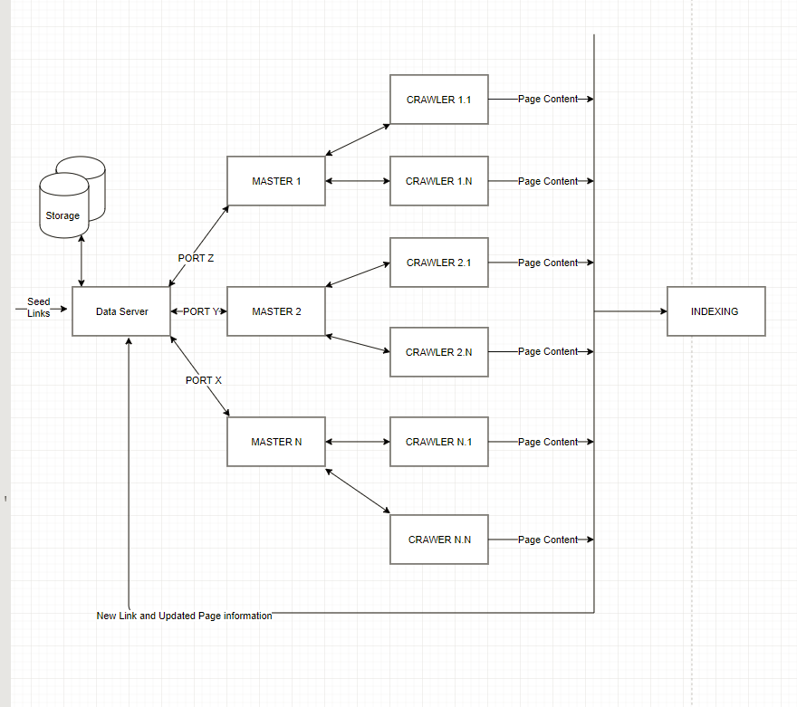

3.2 Architecture Of Search-Engine
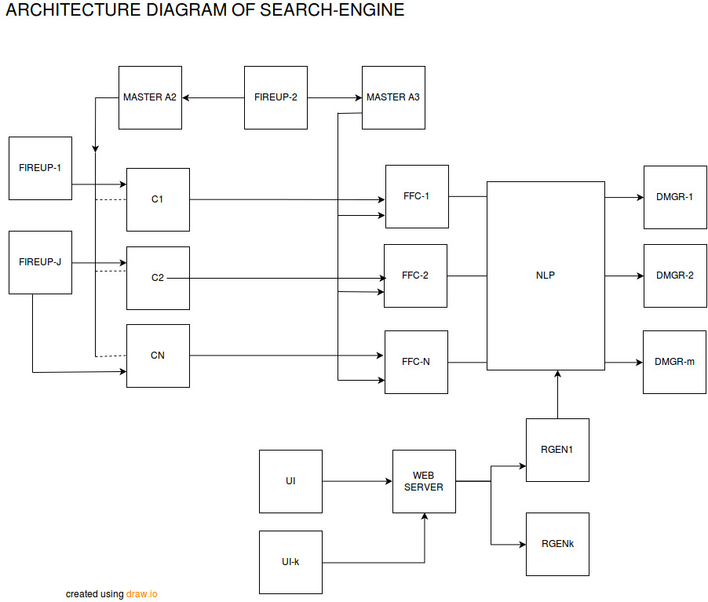

2 SYSTEM MODULES
The whole System is divided into 4 Sub Systems
  - Context Retrieval System ( CRS )
  - Crawler Managing System ( CMS )
  - Data Server ( DS )
  - Queuing System ( QS )

2.1 CONTENT RETRIEVAL SYSTEM
The Context Retrieval System (CRS) connects to CMS and requests for the link , once the links are received the CMS will spawn the worker threads to crawl the pages.
Detail explanation of Context retrieval system on :
- Basic Working Flow
- Alternate Flow
- Class Diagrams
- Modules Communication Messages
- Sequence Diagram
- Data Exchange Formats

2.1.1 BASIC WORKING FLOW

Following are the steps that system will move when CRS is boot-up.

Step 1: CRS will boot up via Standalone application called “FireUP”.
In this Step the CRS will boot up which will take the IP Address and PORT of the Crawler Managing System (CMS) and System output Stream is written to STDOUT which is read by FireUP and displays the output.

Step 2: Connect to Crawler Managing System (CMS)
In this step the CRS will connect to the CMS via IP Address and PORT given by FireUP. On Successful establish of connection CRS will send “CRS_CONNECT” message to CMS and in return the CMS will provide the port on which it will communicate later

Step 3: Reading the previous state of the system.
In this the CRS will read the previous state of the system and decides based on whether on last active state prior to shutdown CMS System was alive or not. If CMS was alive if will send the “CRS_REQ_NLINKS” request link to the CMS else it will report its previous state by sending “CRS_STATE_UPDT” to CMS and then issues the request link message.

Step 4: Crawling the pages
In this step the CRS will spawn the worker threads and then each worker threads will be given link to crawl. The crawled web page is written to the disk with specified name which is later processed by the parser.

Step 5: Parsing the crawled pages
The crawled web pages are parsed by the parser where the context is filtered by removing the advertisements and unwanted comments etc. And then the new links are extracted and filtered based on link “robot.txt” file and then context is ranked by the Page Rank Algorithm along with some additional fields and the filtered context is written to the file where the FFC (Fetch from crawler) System will read the data and will index accordingly.

Step 6: Sending the new links to DataServer
In this new links are sent to the DataServer which are stored and scheduled for re-crawling.

Step 7: Updating the link information to DataServer
After parsing if it is identified that the page is modified then the CMS is notified with “CRS_UPDT_LINKS” message where the CMS will make changes to stored link information in DS (DataServer).

Step 8: Shutdown of System
System can be shut down in 2 ways a) By CMS
b) By FireUP/By user input

Shutdown by CMS: In this the CRS will receive the “CRS_SHUTDOWN” message after that the CRS will send the new links and also the links that are yet to be crawled to CMS and will shut down.

Shutdown by FireUP / user input: In this the CRS will send “CRS_SHUTDOWN” message to CMS along with new links and also the links that are yet to be crawled.

Note: In above cases if the CMS is down/ not responding then the links are stored to the File.

2.1.2 ALTERNATE FLOW
Scenario 1: Unable to connect to CMS initially or received “CMS_CONN_ERR”/“CMS_CONN_LITEXC” message.
In this case the system will shut down.

Scenario 2: When no links are available to crawl.
In this case the worker threads are suspended from the execution and “CRS_REQ_LINK” message is sent to the CMS on receiving of the new links the threads are resumed for the execution.

Scenario 3: Sudden kill of process or sudden termination of process.
This scenario occurs if FireUP is closed unexpectedly or program receives SIGINT or SIGSEGV signals from the OS .In this case a signal handler function will safely shutdown the system by writing the current instance to the file which includes the links that are yet to be crawled etc.

2.1.3 CLASS DIAGRAM OF CONTEXT RETRIEVAL SYSTEM

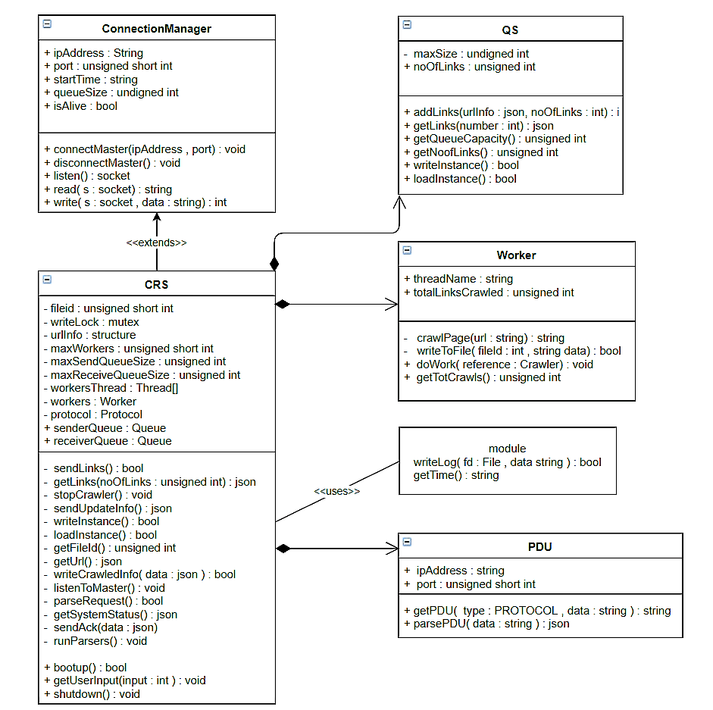
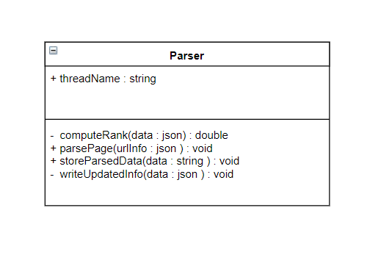

2.1.4 MODULES COMMUNICATION MESSAGES
Conventions: SUCCESS values are positive
FAILURE values are negative

CRS send messages table:
Request messages that Context retrieval system sends to Crawler managing System
Case | Message | Values
Connect request to CMS | CRS_CONNECT | 1
Disconnect request to CMS | CRS_DISCONNECT | 2
Request for new links from CMS | CRS_REQ_NLINKS | 3
Send new links to CMS | CRS_SND_NLINKS_SUCC | 4
No New links to send | CRS_SND_NLINKS_ZERO | -4
Send link update information | CRS_UPDT_LINKS | 5
Reporting previous unreported state due to CMS node down. | CRS_STATE_UPDT | 6
Shutting down the system | CRS_SHUTDOWN | 7

Response Messages from CMS to CRS
Case | Message | Values
Successful accepting the connect request | CMS_CONN_SUCC | 1
Failure in accepting new connect request due to error | CMS_CONN_ERR | -1
Failure in accepting new connect request due to limit exceed | CMS_CONN_LMTEXC | -2
Response for getting new links which CRS has requested to CMS | CMS_SND_NLINKS_SUCC | 2
When no links to send to CRS | CMS_SND_NLINKS_ZERO | -3
Successful update of link info | CMS_UPDT_LINKS_SUCC | 3
Error in update of link info | CMS_UPDT_LINKS_ERR | -4
Successful response to unreported  State of CRS | CMS_STATE_UPDT_SUCC | 4
Failed to update unreported  State of CRS | CMS_STATE_UPDT_ERR | -5
Unable to parse the message | CMS_PARSE_ERR | -6
Successful Disconnect of CRS | CMS_DISCONNECT | 7

2.1.5 SEQUENCE DIAGRAMS FOR CRS

1. Getting HTML Page
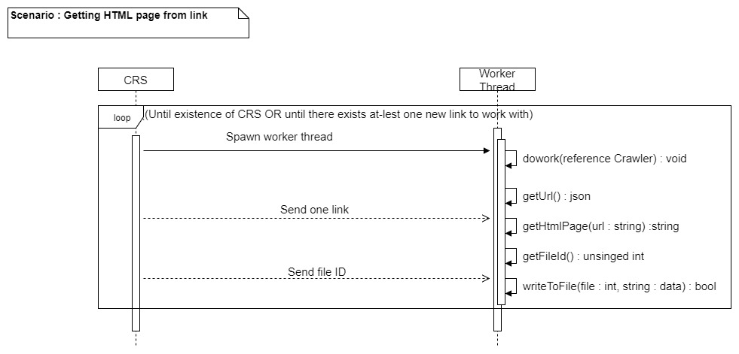

2. Communication between CMS & DS

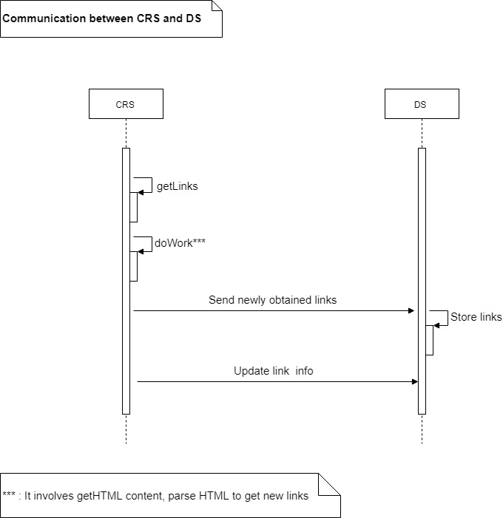

2.1.6 DATA EXCHANGE FORMAT BETWEEN CRS AND CMS
Data is exchanged between Context retrieval system and Crawler managing System in JSON format.

Scenario 1: Connect Request from CRS to CMS
Request Message
{
mode : “REQUEST”,
type : “CRS_CONNECT”,
ipaddress : “192.168.4.4”,
maxQueueSize : 200,
}

Response Message from CMS
{
mode : “RESPONSE”,
type : “CMS_CONN_SUCC”/”CMS_CONN_LMTEXC”,
port : 8925/-1
}

Scenario 2: Link request from CRS to CMS

Request Message

{
mode : “REQUEST”,
type : “CRS_REQ_NLINKS”,
number : 129
ipaddress : “192.168.4.4”,
port : 8925
}

Response Message from CMS

On Successful Receiving of requested links.

{
mode : “RESPONSE”,
type : “CMS_SND_NLINKS_SUCC”,
number : 129,
data : [ {
urlid : 2659,
url : “www.google.com”,
length : 2658987,
depth : 4
},
….
]
}

No Links are available to send
{
mode : “RESPONSE”,
type : “CMS_SND_NLINKS_ZERO”
number : 0
}

Scenario 3: Sending New Links to CMS

If New links are available to send the data sent is

{
mode : “RESPOSE”,
type : “CMS_SND_NLINK_SUCC”,
number : 412,
data : [ {
url : “https://stackoverflow.com” depth : 3,
},
{
url : “https://facebook.com”,
depth : 3
}...
]
}

If No new links are available to send
{
mode : “RESPONSE”,
type : “CMS_SND_NLINKS_ZERO”,
number : 0
}

Scenario 4 : Sending updated link information to CMS

{
mode : “REQUEST”,
type : “CRS_UPDATE_LINKS”,
number : 34,
data : [ {
urlid : 16594,
url : “www.bbc.com”,
update : “YES”,
newLen : 154879,
outlinks : [ {
“www.a.com”,
“www.b.com”,
}
]
}
]
}

Scenario 5: Shutdown of CRS

Send Shutdown message to CMS

{
mode : “REQUEST”
type : “CRS_SHUTDOWN”,
ipaddress : “192.168.4.4”,
port : 8295
}

Response from CMS

{
mode : “RESPONSE”,
type : “CMS_DISCONNECT”,
}

2.2 CRAWLER MANAGING SYSTEM
The Crawler Managing System (CMS) manages the crawlers that are connected by sending new links to crawl and polling the CRS

Detail explanation of Crawler Managing System on:
- Basic Working Flow
- Alternate Flow
- Class Diagrams
- Modules Communication Messages
- Sequence Diagram
- Data Exchange Format

2.2.1 BASIC WORKING FLOW
Step 1: Boot up of Crawler Managing System.
In this step the CMS will be stated with standalone application called “FireUP” will take IP Address and Port as a parameter on which CMS server will start.

Step 2: Returning to previous state.
In this step the Queuing system previous state will be restored and will start listening to CRS systems

Step 3: Registering the Data Server.
CRSMASTER_CONNECT request is sent to Data Server to register and get links to crawl.

Step 4: Sending links to CRS to crawl
In this step the CMS will send links to CRS on request accordingly, if no links are available then error message is send accordingly.

Step 5: Poll the CRS systems periodically
The CMS will poll CRS and get their status periodically, if there is no response from CRS for particular number of times then it will remove the entry of that CRS from the registry

Step 6: Shutdown of Crawler Managing System.
This will issue shutdown message to Queuing System and Data Server and will issue “CMS_SHUTDOWN” Message to all crawlers.

2.2.2 ALTERNATE FLOW
Scenario 1: When unable to register new CRS System
In this case error message is send to CRS System, this error is caused by either maximum crawler limit exceed or any internal socket error.

Scenario 2: When unable to register with Data Server.
CMS will retry to connect Data Server several times. And will shut down ultimately if retry limit is crossed

2.2.3 CLASS DIAGRAM OF CRAWLER MANAGING SYSTEM
CONVENTIONS
CMS: Crawler Managing System
QS: Queuing System
DS : Data Server

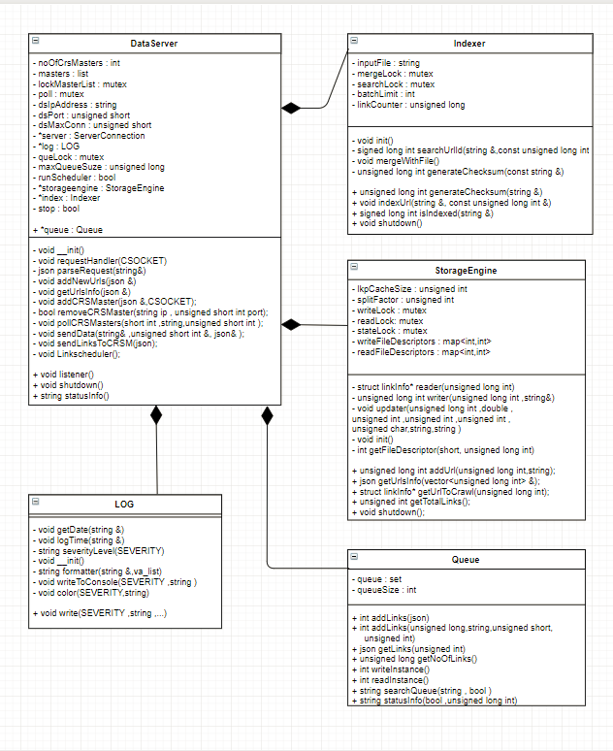

2.2.4 MODULES COMMUNICATION MESSAGES

Conventions: SUCCESS values are positive
FAILURE values are negative
CMS send messages table:
Request Messages that Crawler Managing System sends to Context Retrieval System

Case | Message | Values
CMS request New Links to CRS | CMS_REQ_NLINKS | 1
CMS polling each CRS System | CMS_POLL | 2
CMS sends links successfully to particular crawler | CMS_SND_NLINKS_SUCC | 3
No new links to send | CMS_SND_NLINKS_ZERO | -3
Master shutting down | CMS_SHUTDOWN | 5

Response Message that CMS get from CRS
Case | Message | Values
CRS send connect request to CMS | CRS_CONNECT | 5
Max limit exceed | CRS_CONN_LMTEXC | -5
CRS disconnects from Master | CRS_DISCONNECT | 7
Crawler Requests for new links | CRS_REQ_NLINKS | 8
Data Server sends new links to master | SND_NLINKS_SUCC | 9
Send update link information | CRS_UPDT_LINKS | 10
Report unreported previous state | CRS_STATE_UPDT | 11
Shutting down of Crawler | CRS_SHUTDOWN | 12

2.2.5 SEQUENCE DIAGRAM FOR CMS
1. CMS Registering with CMS

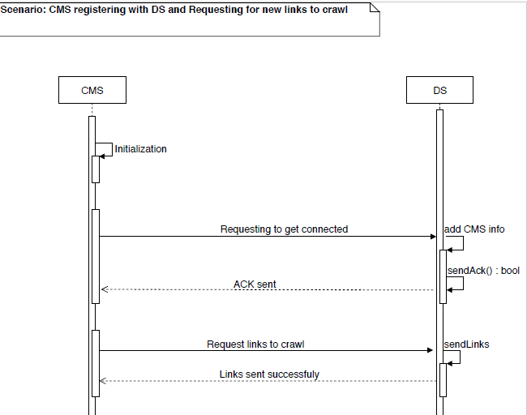

2.2.6 DATA EXCHANGE FORMAT BETWEEN CMS AND CRS
Scenario 1: Requesting for New Links to CRS System

Request Message
{
mode : “REQUEST”,
type : “CMS_REQ_NLINKS”,
number : 123,
ipaddress : “192.168.4.4”,
port : 8125
}

Response Message from CRS System

If new links are available to send the data sent is

{
mode : “RESPONSE”,
type : “CRS_SND_NLINKS_SUCC”,
number : 412,
data : [ {
url : “https://stackoverflow.com” depth : 3,
},
{
url : “https://facebook.com”,
depth : 3
}...
]
}

If No new links are available to send

{
type : “CRS_SND_NLINKS_ZERO”,
number : 0
}

Scenario 2: Sending New Links to CRS System

If new links are available to send the data sent is

{
mode : “RESPONSE”,
type : “CMS_SND_NLINK_SUCC”,
number : 412,
data : [ {
urlid : 1236,
length : 65959,
url : “https://stackoverflow.com” depth : 3,
},
{
urlid : 6516,
length : 594684,
url : “https://facebook.com”,
depth : 3
}...
]
}

If No new links are available to send

{
mode : “RESPONSE”,
type : “CMS_SND_NLINKS_ZERO”,
number : 0
}

Scenario 3 : Response from CRS for polling message

{
mode : “RESPONCE”,
type : “CRS_POLL_ALIVE”,
ipaddress : “192.168.4.4”,
port : 8124,
}

2.3 DATA SERVER

This System stores the link information and assign unique 64 bit long positive number . With the help of 64 bit number we can uniquely identify 18,446,744,073,709,551,616 links . The DS System uses different data structure to store the data .
Indexing are used to store the information each node stores the urlid and url ( link ) and the urlid acts as file offset to access full information of that link

Information stored in file includes different fields
- urlid [ uniquely identifies each url and also acts as file offset ]
- url [ address of the link ]
- length [ length of the web page ]
- inDegreeLink [Other web pages pointing to this page]
- outDegreeLink [This web page pointing to other]
- last crawled [ last crawled data and time ]
- rank [ rank of the page ]
- history [ array which holds information of document modified on last crawled or not ]
- pageTitle [ Title of page ]
- Abstract [Shows first 128 bytes of characters]

2.4 QUEUING SYSTEM
Here we use QUEUE to store and retrieve the links that contain information like urlid, url, its depth, length of page, etc. Here the information is stored in first in first out manner. The queue system is initialized by CMS system . The queue also implements SET feature to remove duplicate links.
The Queuing system holds information on
- urlid [ To identify url uniquely ]
- url [ address of the link ]
- depth [ to recursively crawl child links ]
- length [ length of page that was last crawled ]

Note: The New links with depth = 0 are discarded and are not scheduled for further crawling

Detail explanation of Queuing System:
- Basic Working Flow
- Alternate Flow
- Modules Communication Messages
- Sequence Diagram

2.4.1 BASIC WORKING FLOW

Following are the steps take place when master communicates with the queue:

Step 1: Insert links request.
Here the CMS sends a request of inserting the new links to the QS. Master sends the list of new links. The QS first checks if the new links are being duplicated or reoccur in its previous storage or existing list, and if the links are atomic then these are inserted in the queue. The queue responds to the master with “QUE_INS_SUCC” message.

Step 2: Get links request.
Here the CMS requests the queue to send the specified amount of links. The queue now performs certain tests and sends the list of links along with their information to the master. Now the links been retrieved get deleted from the queue. After successful return of links queue responds by sending “QUE_RET_SUCC” message.

Step 3: Sudden kill or termination of the process.
If the if FireUP is closed unexpectedly or program receives SIGINT or SIGSEGV signals from the OS the queue sends the remaining links in its list to a specific file. Queue sets “QUE_STORE_FILE”. This signal is used and explained in alternative working flow Scenario 1 below.

2.4.2 ALTERNATE FLOW
Scenario 1: Unable to insert the links. This happens:
When queue size exceeds maximum limit. The queue responds master by a “QUE_SIZE_FULL” error message.
When links to insert are repeated (duplication), queue responds by a “QUE_LINKS_DUP” error message.

Scenario 2: Get links has following scenarios:

- Queue is empty. QS responds CMS with a “QUE_SIZE_EMPTY” error message.
- Queue doesn’t contain the specified amount of links. Queue returns only as many links as possible.

2.4.3 MODULES COMMUNICATION MESSAGES
Conventions: SUCCESS values are positive
FAILURE values are negative

Queuing System messages table:
Case | Message | Values
Insertion successful | QUE_INS_SUCC | 1
Queue size exceeds maximum limit. | QUE_SIZE_FULL | -1
Links being repeated while insertion. | QUE_LINKS_DUP | -2
No links available for retrieval during get links request. | QUE_SIZE_EMPTY | -3
Less links available than specified. | QUE_SIZE_LESS | -4
Links are successfully returned to master | QUE_RET_SUCC | 2

2.4.4 SEQUNCE DIAGRAM FOR QS

1. Inserting links to QS from CMS and CMS getting links from QS

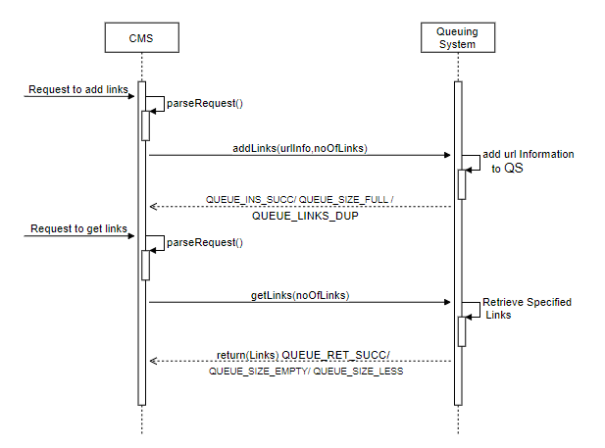

2.5 SCHEDULING POLICY
Determining when to crawl the links is done using probabilistic model which takes past history and determines when to crawl them.
We have taken previous 8 crawl history to predict whether to schedule the link for crawling or not .Initially when the new link is added all 8 history are considered as hits for change then as and when link is crawled the history table is updated accordingly.

Consider the below example
1 | 0 | 1 | 1 | 0 | 0 | 1 | 0

The above bits will evaluate to 178
Thus we get the value between range 0.0 - 1.0 when we take the ration of number of bits set to All bits set and we can predicts whether to crawl or not

Output Value | Time to Schedule
>=0.8 and <=1.0 | Everyday
>=0.6 and <0.8 | 2 day
>=0.4 and <0.6 | 4 day
>=0.2 and <0.4 | 8 day
>=0.0 and <0.2 | 16 day

5 FIREUP APPLICATION

Need for `fireup`. The SE system we were developing was distributed and someone was needed for managing processes in the machines that were involved. The human operators are one of the inefficient way doing it as it requires to remember a lot of commands and arguments which is quite difficult. In the way to ease this process we developed a standalone application called `Fireup` in Java.
`Fireup` is an application used as a proxy to human operator for our SE system. It provides a programmable interface to manage processes in the machines that it runs (of course with some privileges). `Fireup` also provides the GUI to allow user to manually operate it.

Prerequisites.
- Java
How to use.
- Booting up Just run the command to start `fireup` from your command line.
java -jar fireup.jar

- Running programs: After start you can run the programs of your choice in your local machine by specifying them in the text-box `executable` with command line arguments in the `cmd args` text-box. [of course hit Run]. First thing in SE you wish to run is your master. So choose the application and run it with the required args.
- Registering to a master. `Fireup` support a protocol where you can register your machine as a slave to master machine. By which you give privileges to the master to run commands on that machine. The registration process is manual hence you need to know the hostname/ip and port on which master is running. Enter the fields and hit enter.
- You are ready to accept commands. Now your `fireup` is up and running and your master can specify commands to execute.

DESIGN:

i) STARTUP SEQUENCE OF SLAVES

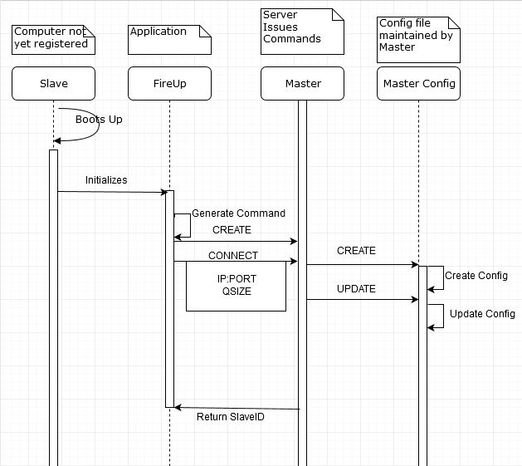

Fig.2 Start-up Sequence

REQUIREMENTS TO MEET FOR SCENARIO

R 1.1.1 - Creation of ‘FireUP’ module. Fire Up’s User Manual.
R 1.1.2 - Request and procuring the config file through ‘FireUP’.
R 1.3 - Use of a communication Protocol

ii) BOOTING UP OF A3 BATCH SLAVES

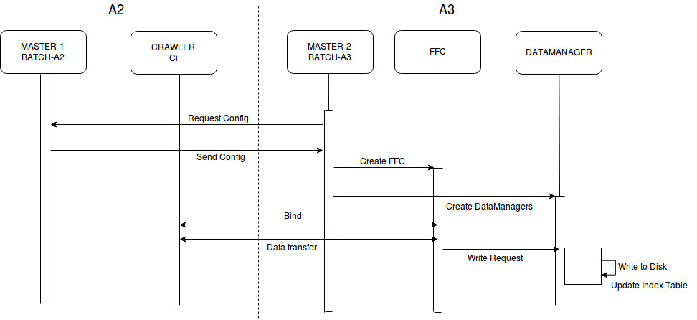
Fig.3 Boot-up of slaves (FFCs and DMGRs)

REQUIREMENTS TO MEET FOR THE SCENARIO

R 1.1.3-Booting up of FFC and Data Manager modules in accordance with configuration.
R 1.3- Use of a communication Protocol
R 2.1-Fetching data from the crawler.
R 2.3-Send data to Data Mangaer.

Fig.4 Preliminary design of Index table

REQUIREMENTS TO MEET FOR SCENARIO
R11.1- Effecient datastructure to get “key-> links”

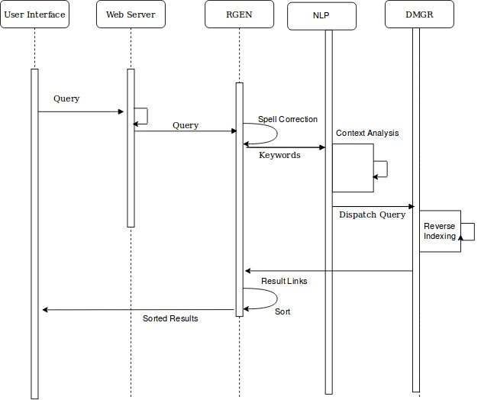
iv)Query Processing and Result Generation:

Fig.5 Query processing and result generation

REQUIREMENT TO MEET FOR SCENARIO:

R12.2-Taking the input Query from the User through UI.
R12.1.- Query processing involves spell check, context analysis and splitting to keywords
R13.1-Receving links from data-managers
R13.2-Sorting links based on their rank.
R14.1-Forwarding results to UI

MODULE DESIGN:

1. Master:

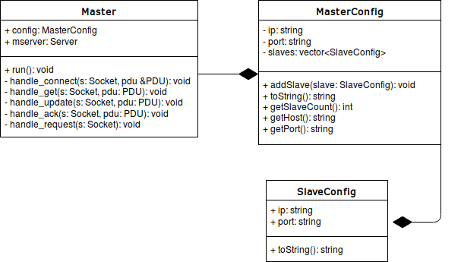
Fig.6.1 class diagram Master A3

2. Fireup:
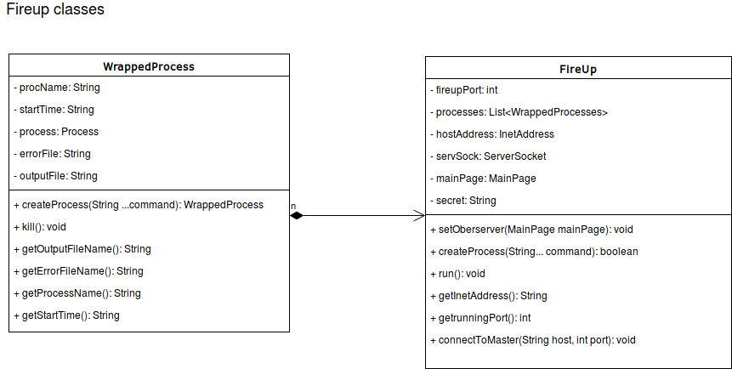
Fig.6.2 class diagram FireUP
3. RGEN:
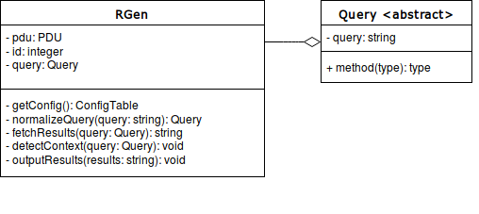
Fig.6.3 class diagram RGEN

4. DMGR
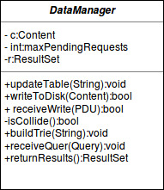

Fig.6.4 class diagram DMGR

User manual for `FireUP`.

Need for `FireUP`.
The SE system we were developing was distributed and someone was needed for managing processes in the machines that were involved. The human operators are one of the inefficient way doing it as it requires to remember a lot of commands and arguments which is quite difficult. In the way to ease this process we developed a standalone application called `FireUP` in Java.

`FireUP` is an application used as a proxy to human operator for our SE system. It provides a programmable interface to manage processes in the machines that it runs (ofcourse with some privileges). `FireUP` also provides the GUI to allow user to manually operate it.

Prerequisites.
1. Java

How to use.

1. Booting up
Just run the command to start `FireUP` from your command line.
java -jar fireup.jar

2. Running programs:
After start you can run the programs of your choice in your local machine by specifying them in the textbox `executable` with command line arguments in the `cmd args` textbox. [of course hit Run]. First thing in SE you wish to run is your master. So choose the application and run it with the required args.

3. Registering to a master.
`FireUP` support a protocol where you can register your machine as a slave to master machine. By which you give privileges to the master to run commands on that machine. The registration process is manual hence you need to know the hostname/ip and port on which master is running. Enter the fields and hit enter.

4. Whoa! You are ready to accept commands.
Now your `FireUP` is up and running and your master can specify commands to execute.

The programming interface.

The `FireUP` provides a simple programming interface where a master can specify commands to execute on the machine. This requires the `FireUP` to be registered to the master which is done in previous step.

The `FireUP` uses json as a standard to communicate as it’s easy to read and understand. The fields of the protocol is given in below table.

1. Connect request.
The connect request is sent by the `FireUP` to the master with the the hostname/ip and port on which `FireUP` is listening. You need these to communicate with `FireUP`, so better save them. This request also sends you a `key` which is used for security purposes. You need to save this as you are supposed to send this key in next communications with `FireUP`.

2. Commands
The commands are sent by the master to `FireUP` to execute. This includes 4 important fields
a. Key //secret key given to you
b. Command //one of the commands described below.
c. Executable //executable file name/path.
d. Arguments //arguments to the executable.

Fields in the PDU.

Field | Possible Values
Key* | A number 65536
Command | CREATE, KILL,CONNECT
Executable | A valid executable file path
Argument | A string of arguments
Host | Host on which `FireUP` is running
Port | Port on which `FireUP` is listening.
Table -3. FireUP arguments
R 9.3 Protocol used by modules to communicate.

The modules in the system need to communicate with others inorder to resolve their data-dependencies, eg. FFCs need to communicate with the crawlers to get the web-content. We introduce a simple protocol to communication between the modules. Which is discussed below. Each PDU is in the JSON format to ease the parsing process. The fields in the PDU are discussed below.

Table-4. PDU fields

Parameter | Description | Possible Values
Method | what do you want | GET, CONNECT, CREATE, UPDATE, KILL, ACK
receiver_ip | the ip of host this packet is being sent to | valid ip address
receiver_port | the port on which the peer is listening | valid port number (not a string)
sender_ip | the ip of the sender host | valid ip address
sender_port | the port from where you are sending this PDU | any valid port number
Who | the class name of sender | CRAWLER, MASTER, FFC, DMGR, WS
Whom | the class name of receiver | CRAWLER, MASTER, FFC, DMGR, WS
Data | data needed for processing the request | any valid json string

// a sample PDU.
{
"method": "GET",
"receiver_ip": "123.231.212.100",
"receiver_port": 3475,
"sender_ip": "122.123.124.135",
"sender_port": 2343,

"who": "crawler",
"whom": "master",

"data": "a_json_string"
}

WORD ANALYSIS THROUGH NLP (Natural Language Processing):

Input: Single word
Output: Bag of words.

The processed query is segmented into individual keywords.
These keywords act as input to the NLP model.

The Output of the NLP module is a bag of words, which are related to the input keyword.
The output words are the most co-occurring words for the given keyword.
Co-occurrence to the given keyword act as the context.

NLP Module
Input Keyword
Bag of words

DOCUMENT

WORD SOURCE
BUILD DICTIONARY
DICTIONARY

TRAINING

WORD SOURCE:
English Dictionary like Webster’s or Pan Am.
The words will be appropriately formatted, to ease processing and persisted in a file.

BUILD DICTIONARY:
- Each word from dictionary is picked and it is entered in the Trie Data-Structure.
- Word is ignored for special characters and converted to small caps.

DATA- STRUCTURE:
Trie- Datastructure is a conventional datastructure used to maintain Dictionary.
We have used a customized version of Trie, that also stores additional information. More on that later.
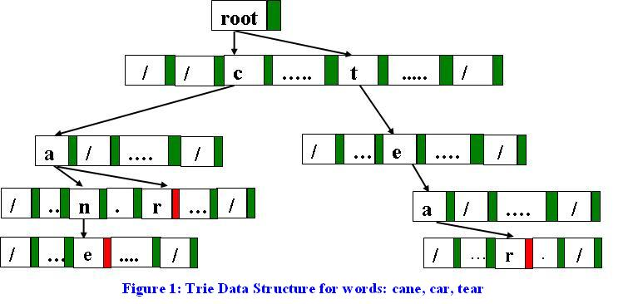

Trie Searches a word in O(n) complexity where, n is the length of the word. Trie also bypasses, the presence of any other words, hence making efficient searches in O(n).
- A complete word is indicated by a terminal byte to indicate end of a word.
- Reverse-Indexing is also done with each complete word with associated document
- Each word in Dictionary is associated with a key, which is used later.

ADVANTAGES OF USING TRIE:
- String comparison is fast. O(n) time complexity.
- Simultaneously we would also be getting the document where the word is occurring in O(1) time.
- Efficient to add new word O(n), where n s the length of the word
- Efficient to get the index associated with the word O(1)
DISADVANTAGES OF USING TRIE:
- As the size of dictionary grows large, the trie would occupy more memory.
- As the number of document increase, the associated of word with doc consumes large memory in Ram.
- Writing to the disk and fetching of trie causes, additional time penalty.

ROLE OF DICTIONARY:
- Find the word being present in the warehouse.
- Can serve for spell correction, prediction.
- Gives index associated with the word.
- Add any new word not found , but sourced from authentic document (rank > threshold).
- Serve as the hub for any reference to a word.(String)

TRAINING:
We can use the incoming documents to train and modify the word vectors to get a better sense of language analysis.
ROLES OF TRAINING:
- Make words semantically similar group together more often.
- Predict the words that usually co-occur with one keyword.
- Make searching more semantic friendly rather than pure key based.

WORD REPRESENTATION:
For better context analysis, we represent each word with a corresponding vector.
WORD: “Aardvark”
VECTOR: [0.4,0.67,0.45,0.56,0.34] is a 5 dimension vector.
Here increasing the dimensions conventionally, yield better sensitivity.
We’ll get to the values and how they are derived later.

ADVANTAGES:
- Representing word as a vector value can help us differentiate as well as get to know the context associated with the word, rather than the word itself.
Example: American government banks on the private banks to stabilize the economy.

Here the word vectors for banks are different. First banks is a verb, whereas latter is a noun.
DISADVANTAGES:
- Representing a single word with a vector of N Dimensions is computationally expensive.
- In order for greater subtlety and context differentiation, we need very good, assorted training dataset.

MODEL:
The model for training the word vectors is by “Skip-Gram” method with soft-max function.

1. Here there are two category of words.
i) Main word: the word, under consideration
ii) Context word: the word that co- occurs with the main word.

AIM: The aim of the model is to predict, most probable co-occurring word for the given main word.
If this could be achieved with reasonable accuracy, the word vectors would be reflecting semantic relations between the words with reasonable accuracy.
PROCEDURE:
For every word ‘w’ there will be two vectors associated with it.
One is, for ‘w’ as main word and for ‘w’ as context word.
TRAINING DATA:
The dataset for training must have following desirable qualities.
- The information presented should be authentic, factual, free from any spam
- The use of natural language, English in our case must be same as used for functional communication.
- The documents should cover usage of words in very assorted manner.
STEPS INVOLVED:
- For a word ‘w’ in test data, extract the corresponding main-word vector
- Within a window of ‘k’, extract the words and their corresponding context vector
- Predict the probability of the words co-occurring with the word ‘w’.
- Apply the loss and propagate the loss / difference with observed behavior in step2 with calculated behavior in step-3.
- Apply the same steps for rest of the training set.
SKIP GRAM FORMULAE:

Here t indicates the entire corpus for training.
W is the window size.
Uo is the context word.
Uv is the input word.

ILLUSTRATION:

I had a dove and the sweet dove died.
Context word.

Context word Input word/main word under consideration.

- We extract the word vector for sweet (input word), suppose V=[0.3,0.32,0.98,0.78,0.1]
- We calculate the dot product of V with all context word vectors, suppose context word is “dove”, and its vector is C= [0.23,0.89,0.77,0.56,0.24].
- We apply soft max formula:
This gives the probability distribution of vectors co-occurring with word V.
- We apply the loss function mentioned above, to get the gradient to make adjustment to vectors.

Indexing: R11.1

The web-content is stored in the File-System.
The crawled data is stored in File System.

Each Document is analysed keyword wise.
Each keyword is associated with a score.

Word in title->10000
Word in Header->1000
Word in Paragraph->100
Word in link ->10.

Each score is normalized according to number of occurrences to the unique words present.
This ensures spam control.
Structure of Document Index.

Document id=1
Keyword | Weight
Universe | 9000
.. | …
Earth | 6789

Each Document is analysed and a central Index Table is updated after the analysis is done on each document.

Structure of Central Index.

Keyword | DocId
Aardvark | {1,67,89,45}
Amygdala | {90.91}
… | ….
Zebra | {32,23,78,64}

Procuring the DocId, Peek into the value associated with keyword in the Document.

Keyword | DocId | KeyWord | Weight
Zebra | 32 | Zebra | 60.
Zebra | 23 | Zebra | 800
Zebra | 78 | Zebra | 4500

The Documents are sorted according to decreasing order of Weights.
Document URL’s are procured and sent to RGEN (Result Generator).

R14.1.Output of the Document links through UI.

The user interacts with the system using user interface.
The Input of the Query is

Search Interface.
This is provided to the user through a web-browser. It allows the user to search documents on the web and view them by giving access to the docs through hyperlinks. Below is the prototype of the UI.

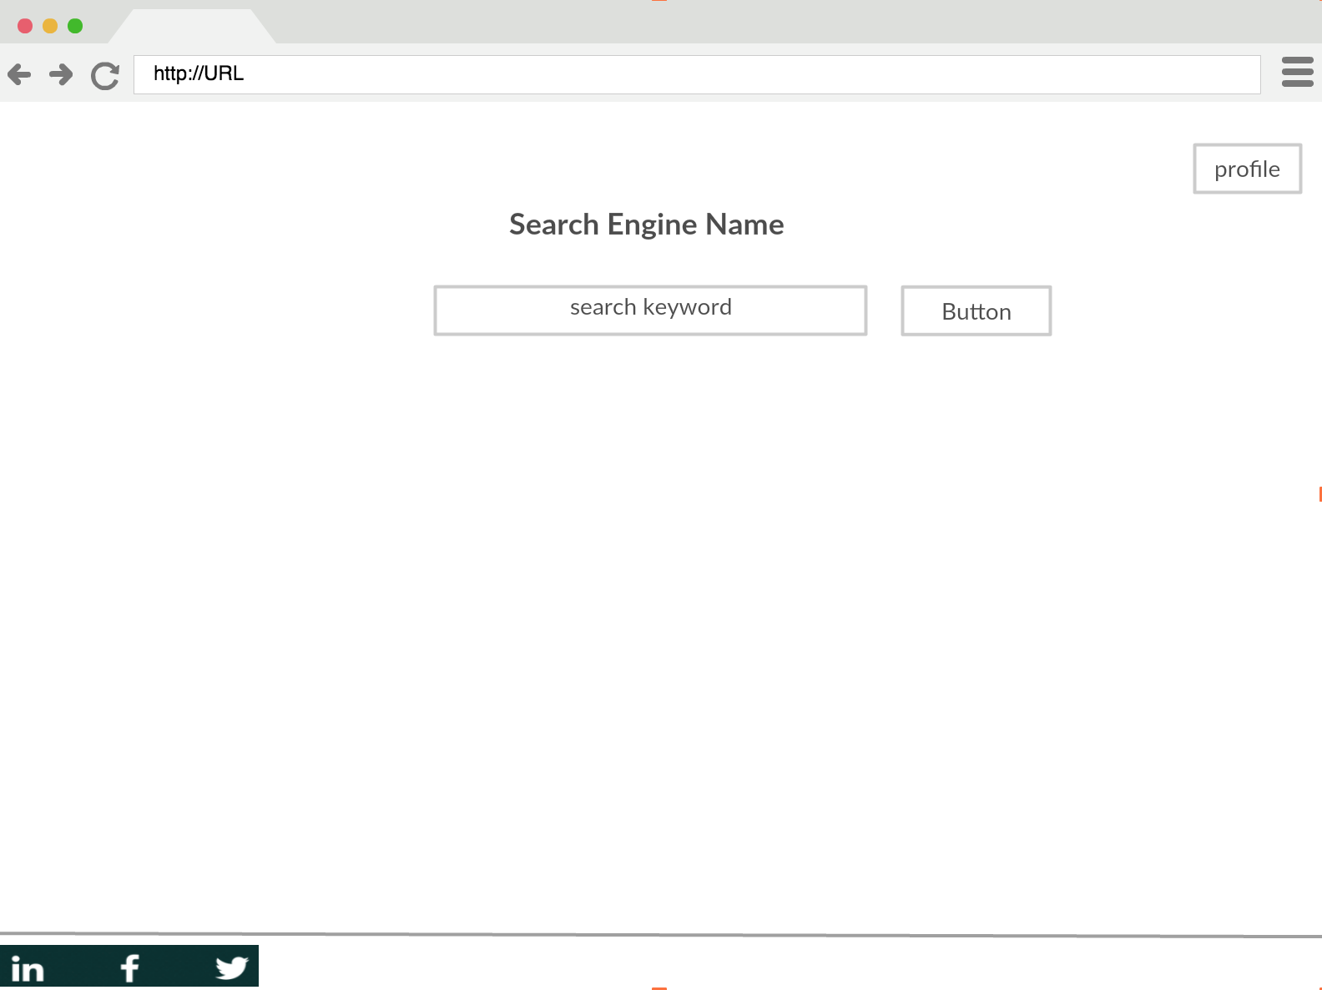

Figure 1. Search Page.

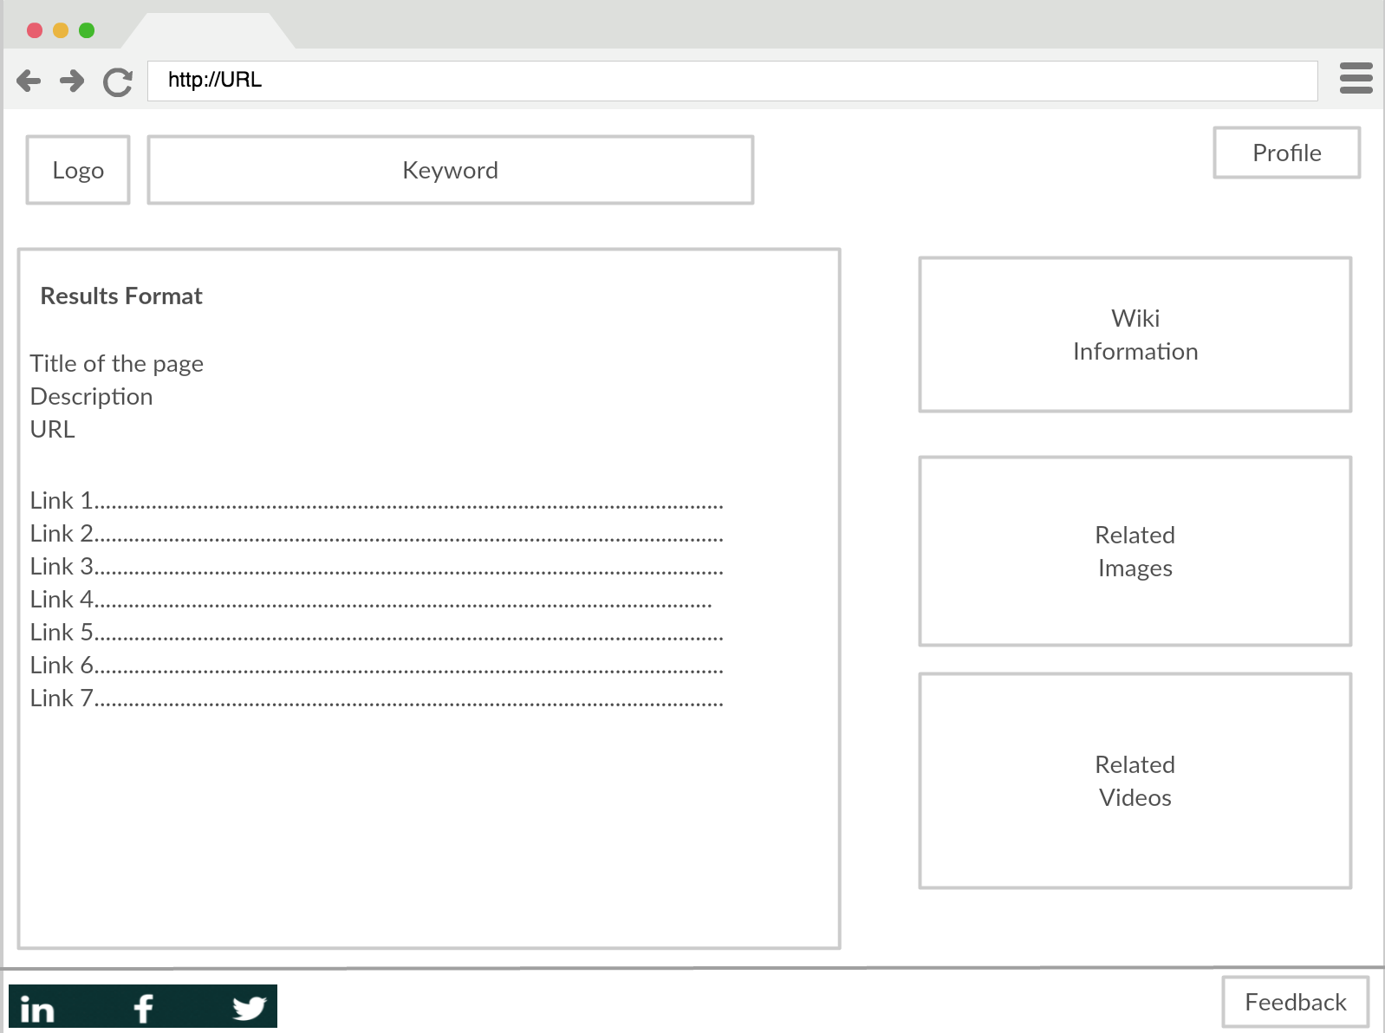

Figure 2. Results Page
How the search works.

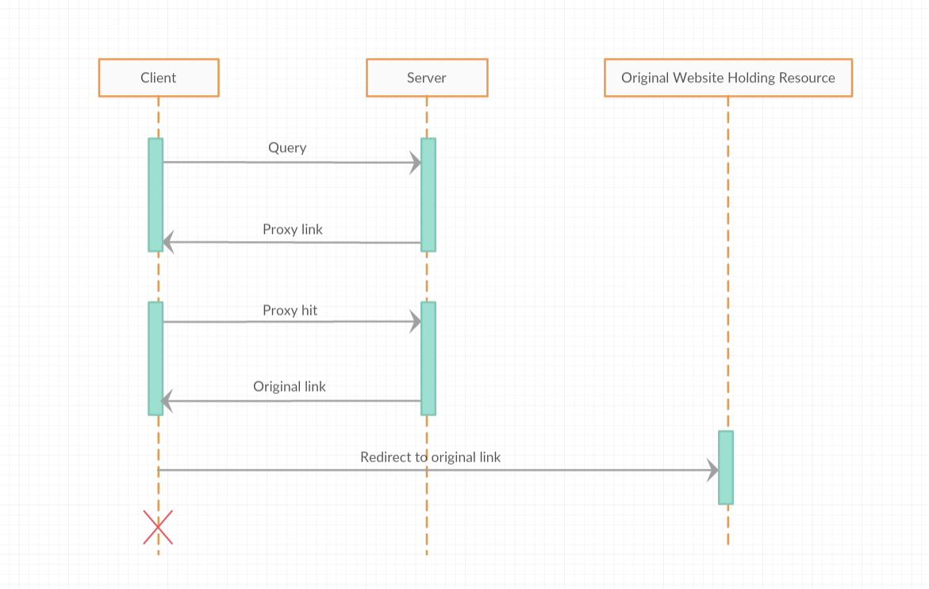

Figure 3. Search process

NR 3-UI for Monitoring processes.

Requirement NR3.
A software to monitor the processes running on different machines by which we can maintain and debug the system.
NR3.1 The system needs to probe the processes periodically and list their status.
NR3.2 Allow the user to set the frequency.

Probing PDU.

Request:
{
“method”: “GET”,
“resource”: “status”,
...
}
Response:
{
“status”: “UP”,
“starttime”: “30 Nov 2017 21:34:45”,
“pid”: 123,
“data”: “some extra info for further extension”,
...
}

Concrete Requirements:
NR3.1: Monitoring System which probes every modules and reports their Status.
NR3.1.1 | Get details about the domain. List the nodes in the domain.
NR3.1.2 | Get details about the node.
NR3.1.3 | Get details about the processes.
NR3.1.4 | Get status from master through http request and display the results.
NR3.1.5 | Create user authentication to perform various actions on domain.

Layout for Monitoring System.

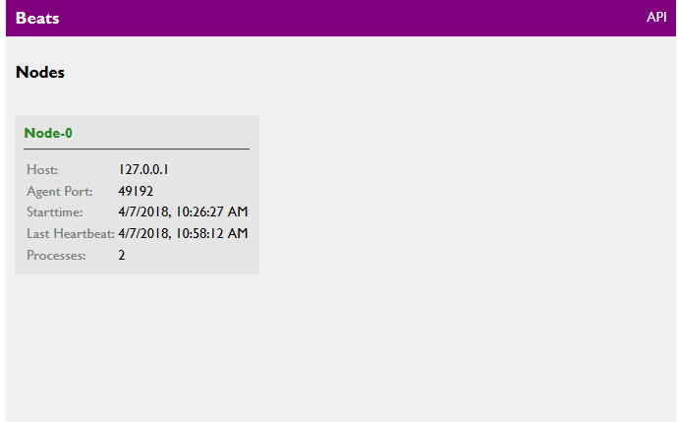

Concrete Requirements NR3.1.2
NR3.1.2.1 | Details of the nodes like Node-id,memory availability,start time ,heartbeat,etc.
NR3.1.2.2 | Perform actions like shut down the node.
NR3.1.2.3 | List the processes running in it.
NR3.1.2.4 | Link to navigate where details about process can be shown.

Layout of the Monitoring for Node.
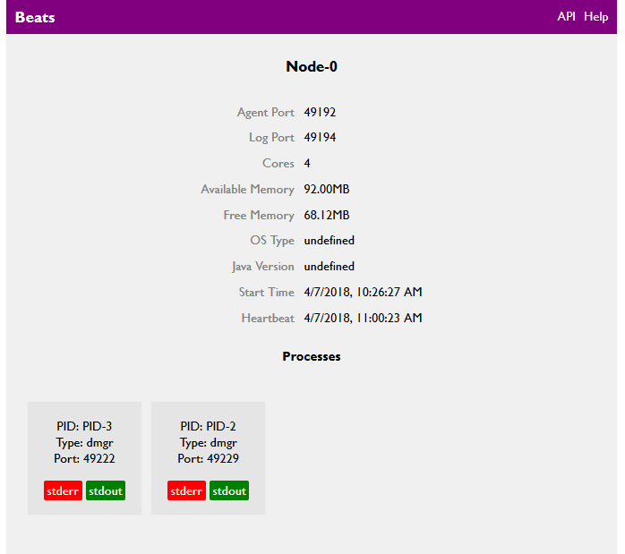

Concrete Requirements of R3.1.3
NR3.1.3.1 | Details about process like process id,port,host,heartbeat,etc.
NR3.1.3.2 | Perform actions like kill the process.
NR3.1.3.3 | Navigate to a link where stderr or stdout files can be viewed.

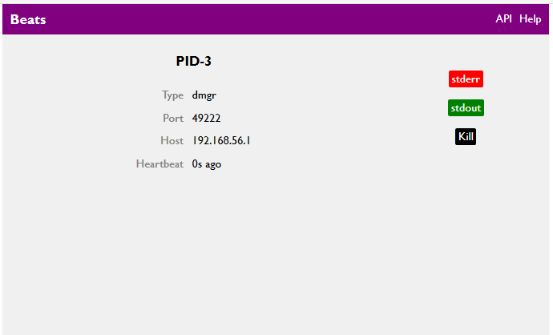

TEST CASES FOR THE Monitoring UI:
Test Cases test the fulfilment of
NR3.1.1,3.1.2,3.1.3 and 3.1.4
T1 | -Display list of nodes with some details like :  - Host  - Agent port  - Start time  - Last heartbeat  -Perform actions like :  - Shut down  - View log  -Display list of processes running on the node.  -Navigate to link having details of the process.

T2 | -Display all information of the node :  - Agent port  - Log port  - Cores  - Available memory  - Free memory  - OS type  - Start time  - Last heartbeat  -Perform actions like :  - Kill node  - View log  -Navigate to link showing all details of nodes.

T3 | -Display all information of process like :  - Port  - Type  - Host  - Last heartbeat  -Perform actions like :  - Kill / stop the process  -Navigate to links with stderr and stdout files

